Seminar Report

On

Learning Analytics Tool for Predictive Modeling on MOOCs for professional Learning

By

Mehak Nargotra

TCOB10

Under the guidance

of

Prof. Smita Khot



Department of Computer Engineering

Dr. D. Y. Patil Unitech Society’s
Dr. D. Y. Patil Institute of Technology
Sant Tukaram Nagar, Pimpri, Pune-18
Affiliated to Savitribai Phule Pune University, Pune
[2018-2019]

Department of Computer
Engineering,

Dr. D. Y. Patil Institute of Technology, Pimpri,Pune

CERTIFICATE
This is to certify that Mehak Nargotra from Third Year Computer Engineering has successfully completed his / her seminar work titled “Learning Analytics Tool for Predictive Modeling on MOOCs for professional Learning” at Dr. D. Y. Patil Institute of Technology, Pimpri, Pune in the partial fulfillment of the Bachelor’s Degree in Engineering

Prof. Smita Khot | Dr.S.N Mali | Dr. Pramod Patil
(Seminar Guide) | (Principal) | (Head Of Department)

ACKNOWLEDGEMENT
It gives me a great pleasure and immense satisfaction to present this special topic seminar report on Learning Analytics Tool for Predictive Modeling on MOOCs for professional Learning to Make best use of machine learning to reduce accidental death, expert guidance and focused direction of my Prof. Smita Khot Guide to whom I express my deep sense of gratitude and humble thanks, for his valuable guidance throughout the presentation work. The success of this seminar has throughout depended upon an exact blend of hard work and unending co-operation and guidance, extended to me by the superiors at our college.
Furthermore, I am indebted to our Head of Department Dr. Pramod Patil and Principal Dr. S. N. Mali whose constant encouragement and motivation inspired me to do my best.
Last but not the least, I sincerely thanks to my colleagues, the staff and all others who directly or indirectly helped us and made numerous suggestions which have surely improved the quality of our work.
Mehak Nargotra

ABSTRACT
Educational technology has obtained great importance over the last fifteen years. Learning analytics and Massive Open Online Courses (MOOCs) are two of the most relevant emerging topics in this domain. Since they are open to everyone at no cost, MOOCs excel in attracting numerous participants that can reach hundreds and hundreds of thousands. Massive Open Online Courses (MOOCs) appeared as a proper way to provide lifelong learning for potential learners of both professional and academic settings. Even Industry leaders can benefit from these courses because they foster the professional development of their employees in their industry.
Despite these benefits, these online courses continue to register a high dropout rate and a vast number of their learners do not acquire the certificate provided at the completion of the course. A predictive modeling tool was proposed with several Machine Learning algorithms (for generating Predictive Models) and feature engineering in MOOCs data integrated to contribute to this specific issue. The proposed tool predicts two situations: which learners are likely to leave the course (dropout) and which learners are expected to pass the course (certificate acquisition). The tool was tested in fifteen deliveries of seven MOOCs. Initial results provide interesting information, for instance, that the accuracy of predicting certificate acquisition is higher than the precision of predicting dropout for all algorithms.

KEYWORDS
Lifelong Learning, Professional Learning, Learning Analytics, Educational Data Mining, Machine Learning, MOOC, peer interactions, prediction model , massive open online course, dropout rate, reasons for dropout, participants’ engagement, motivation, behavioural patterns.
Table of Contents

- Introduction
- Introduction to MOOC
- edX vs Coursera
- Motivation
- Objective of Work
- Organization of the Report
- Literature Survey
- Introduction
- Methodology
2.2.1. Course Selection
2.2.2. Attribute Engineering
2.2.3. Dataset Description
- MOOC Dropout and Completion: Existing Evaluations
- edX-MAS+ Tool
- The Proposed Approach
- Dropouts in edX Courses
- Accreditation of edX courses
- edX-MAS+ Modules
- Import Course Module
- Model Generation Module
- Visualize and Export Module
- Result
- Results obtained using edX-MAS+
- Graphical Result for certificate and dropout prediction
- Graphical Result for certificate prediction
- Applications and Future Work
- Applications of edX-MAS
- Future Work
- Conclusion
- References

CHAPTER 1

INTRODUCTION

Introduction to MOOC
It started as an idea in 2006 and has developed into full-blown learning sources, for many, since 2012. A phenomenon that has become more widespread than Starbucks and its worldwide reach, MOOC has captured the focused attention of 81 million students, more than 800 participating universities, and has close to ten thousand credible courses in the internet universe. There are over 9000 MOOC courses floating about with a handful enjoying the celebrity stardom. Many of these MOOCs also provide credentials like online degrees, professional certificates.
Nowadays, Massive Open Online Courses (MOOCs) are featured in several knowledge areas as a proper way to provide lifelong learning for potential learners of both professional and academic settings. For instance, with the edX platform, it is found MOOCs for Industrial Engineering and Engineering Management.MOOCs allow the collection of a significant amount of data and therefore fall within the scope of Learning Analytics (LA). LA is an emerging area of study, related with Big Data area, which supports the development of methods for exploring, analyzing, and visualizing data from online educational environments.
MOOCs present a potentially useful mechanism for supporting and enabling professional learning, bringing diverse groups of learners together, united by common (or at least complementary and overlapping) learning needs. In this way, MOOCs could serve as a catalyst for the formation of heterogeneous learning communities that facilitate knowledge exchange. An underlying assumption is that learners have the skills and dispositions necessary to learn autonomously and socially within the MOOC. However, by definition, MOOCs attract a broad range of learners with diverse dispositions who differ in their ability to self-regulate their learning (Milligan, Littlejohn, & Margaryan, 2013). There is evidence that learning strategies in MOOCs are influenced not only by learners’ motivation and confidence, but also by the structure of the course, the delivery environment, and the perceived value of learning.
However, MOOC courses continue to register a high dropout rate and a vast number of their learners do not acquire the certificate provided at the completion of the course. There are several reasons why a learner might leave a MOOC course: no initial intention on ending the course (curious learners), not enough time for self learning activities, loss of interest, difficulties with contents or unwillingness to complete final tests and pay the certification fee. Early prediction of learners who are likely to drop out would better inform instructors on their mentoring. Learners would also benefit from such a tool that predicts early dropout because it supports educational recommendation and warning systems to
provide relevant advice for their progress. The common objective of the proposed tool is to improve course contents and consequentially minimize the high dropout rate, as well as promote quality lifelong learning.

    - edX vs Coursera
edX: edX was founded in 2012 by MIT & Harvard University, each having contributed $30 million to kick startthe project. Unlike its peers, edX offers university level courses as a non-profit education project on an open-source platform that is freely available. The courses are channeled by some of the world’s leading universities. The classes (online) are interactive in nature, with the opportunity for students to practice their understanding. Each course has teaching assistants, students are able to discuss the course on forums, pose questions and interact with their fellow students or the teaching assistants.
edX relies on supportive contribution to maintain the non-profit education project and continue its research in learning. While you can enroll for a class just for the learning, edX provides an edX Verified Certificate for those who desire a proof of their course completion, for jobs, schools, etc. There is a reasonable minimum fee, however, most edXfunds are sourced from the above-mentioned contributions. Financial assistance, class creation, and other improvements are all drawn from those funds.
Coursera: Founded in 2012 by Stanford professors Andrew Ng and DahpneKoller, it is the most popular MOOC around the world. Lasting of the order of ten weeks, the courses are designed by top university professors, and their teams. They have assignments, quizzes, and even final capstone projects, or exams in lieu of traditional university classes. Since 2014, Coursera integrated self-paced courses,with no deadlines, to counteract the traditional structures. However, to keep up with an active discussion forum and peer grading, the structure later shifted to soft-deadlines. Each Coursera session now runs almost every month, thereby allowing students the flexibility of shifting to the next session in case of interruptions. In the end, every completed course leads to a completion certificate that is directly shareable on other platforms, such as LinkedIn. Coursera doesn’t just limit itself to courses, but has expanded into whole areas or fields of training.
Thus, it can be said that edX which is a bit costly as compared to Coursera provides one of the best teaching styles. It provides assignments which help in learning and enhancing our knowledge.In coursera students might acquire a financial aid but inspite of that the materials and definitely not the certificates are not provided completely whereas in edX you get access to all the important notes and content followed by the certifications completely.

Motivation
In the state of art, it is found a significant number of LA tools that also provide predictive modelling based on Machine Learning techniques in order to detect learners at risk of adverse situations (i.e., dropout) or perform an in-depth analysis from the learners’ contributions in online discussions boards.

Objective of work
The main objective is to present a Learning Analytics Tool for Predictive Modeling of Dropout and Certificate acquisition on MOOCs, called edX-MAS+. Industry leaders would benefit from these courses because they can foster professional development and self-learning and specialize their employees in their work industry. Any of the previously mentioned tools, such as the proposed tool in this project (edX-MAS+), may be used to guide these essential efforts of the industry leaders.
To begin with an introduction of the tool edX-MAS+ and the primary approach of the generation of Predictive Models for edX MOOCs. A study of dropout in UAM edX courses is provided for dropout prediction. The third section describes the three interconnected modules of edX-MAS+. The fourth section presents some of the results obtained with the proposed model. Finally, ending with a conclusion.

Organization of the report
The tool presented provides extensive compilation of functionalities that allow importing course data, processing it to obtain input variables and select which of them to use to feed one of the ten integrated Machine Learning algorithms to train a model per course day or week for dropout or certificate acquisition prediction.
This tool is a modular and scalable application that, based on the data collected from a MOOC course, allows the simple application of a complete Data Science process, where Machine Learning algorithms are applied to generate predictive models which could be used to predict which learners have passed the course and therefore obtained a certificate.
It allows analyzing variable importance and evaluation metrics and the re-training of a new algorithm with the same or different set of input variables and comparing it with other algorithms previously used. Finally, it is possible to save and export course variables, results, and graphics obtained for further work.

CHAPTER 2
LITERATURE SURVEY
2.1 Introduction
Many professionals operate in settings where profound social and technological changes are fundamentally changing the nature of work (Dall’Alba, 2009). Conventional forms of professional training are losing currency, particularly where they do not address critical dimensions of professional learning important for the contemporary workplace (Littlejohn & Margaryan, 2013). First, job roles are becoming more specialized to the point that the learning required for a specific role has to be personalized. Conventional professional training, such as workshops and courses, is useful in allowing groups of people to reach a general level of competency. Nonetheless, these forms of training generally do not support bespoke learning. MOOCs potentially allow for personalized learning by giving professionals opportunity to align formalized learning with their practice, learning (via the network) with others who share similar and complementary experience and expertise. Their potential depends on how professionals align their personal learning goals with learning in the MOOC.
Participation in MOOCs and Online Discussions: Irrespective of differences in their pedagogies, all MOOCs appear to face the common problems of high attrition rates.
Large proportions of learners who enrol on courses never participate and many others leave courses after their first visit. In a study, Khalil and Ebner found out the reasons behind these high attrition rates, identifying some of the factors as follows:
- lack of time
- loss of motivation
- feelings of isolation
- lack of interactivity in MOOCs
- insufficient background knowledge and skills to cope with what is being taught in MOOCs.

2.2. Methodology

2.2.1. Course selection
Firstly, a suitable case study courses were selected from those available in FutureLearn and edX, delivered by the collaborating institutions (to ensure student datasets would be readily available). The criteria used in the manual selection of these courses included: they should be of a similar discipline or theme in the broadest possible way (i.e. either from STEM subjects or social sciences), and of a similar duration. In the case of there being more than one matching pair, preference would be given to those for which the duration is the longest. If more than one “run” of these courses had data available, those for which the cohorts were the largest would be selected.
After applying the above criteria to the courses available (a total of 22: 8 in edX and 14 in FutureLearn), the following were selected: the 7-week-long edX course in Spanish history titled “The Spain of Don Quixote”2 (Quijote501x) and the 6-week-long in archaeology titled “Archaeology of Portus: Exploring the Lost Harbour of Ancient Rome”3 (Portus). Referring to these courses in the rest of this paper as the edX MOOC and FL MOOC respectively. Both courses had a certification available to those learners who meet the platform completion criteria, and both have some sort of assessment (exercises and quizzes, respectively).

2.2.2. Attributes Engineering
For both cases, in a pre-processing stage, the value of a number of attributes were computed from raw data available in each context, such as the number of sessions, the number of days, the number of events, total time spent on exercises/quizzes and the number of social interactions in discussions forums). Following this, machine learning techniques were applied to the pre-processed data to predict attrition levels for each dataset (the algorithms mentioned previously in the “Machine learning” subsection).
The prediction is performed looking forward to the week ahead, and it becomes more
accurate when there is more information available, as would be expected. However, this point was established by which an early warning could be provided with a reasonably high degree of accuracy for each case. This was interesting to ascertain as there is a clear trade-off between accuracy and timeliness of the prediction: clearly there is less value of a dropout prediction after the student has already left the course, whereas a timely prediction (even if less accurate) could enable an intervention which might help the student to continue).
2.2.3. Datasets description
The anonymised datasets for each MOOC were processed using an adaptation (of the early stages) of Jo et al’s pipeline for expediting learning analytics [25], as follows:
3. datasets were pre-processed and cleaned;
4. attributes used as predictors were extracted; and
5. a number of predictive models were generated.
2.3. MOOC Dropout and Completion: Existing Evaluations
Large amounts of data are collected by the major MOOC platforms, but access to this is not generally available. Several evaluations have been published by specific institutions providing data and analysis on courses they have delivered. These provide a valuable source of information on a variety of aspects relating to learner background, engagement and attainment. Focus is on data relating to participation and dropout rates.
The University of Edinburgh launched six MOOCs on the Coursera platform in January 2013. The information in this paragraph is obtained from a published report on these MOOCs .The six “short, fully-online” courses ran for 5-7 weeks and attracted a total initial enrolment of 309,628 learners. Six different course structures were developed and, in addition to the usual features of the Coursera platform, new methods of content delivery and collaborative working were introduced.
Evaluation of the Edinburgh MOOCs revealed that 123,816 of those enrolled (about 40%) accessed the course sites during the first week (‘active learners’), of whom 90,120 (about 29%) engaged with the course content. Over the duration of the course, the number of active participants rose to 165,158 (53%). As a gauge of persistence, 36,266 learners (nearly 12%) engaged with week 5 assessments. This represented 29% of initial active learners, although interestingly there was a large variation across the six courses ranging from 7% to 59%. Obtaining a statement of accomplishment required attainment of a certain percentage in the assessment (the specific level varying between courses) and this was achieved by 34,850 people (roughly 11% of those who enrolled). This report provides more demographic data and analysis, but engagement and dropout rates are not investigated further with respect to these.

CHAPTER 3
edX-MAS+ TOOL

3.1 THE PROPOSED APPROACH: edX-MAS+ TOOL
A modular tool for supporting the generation of predictive models for edX MOOCs, whose name is edX-MAS+: Model Analyzer System Plus for edX MOOCs was proposed. edX-MAS+, based on the data collected from edX MOOCs, implements Educational Data Mining and Data Science processes, where Machine Learning algorithms are applied to generate predictive models that can be used to predict which learners have left (dropout) or passed the course (and therefore obtained a certificate).
EdX-MAS+ calculates several input variables, which are indicators that measure the interaction and time invested with the platforms, activity, consistency, and effectiveness of learners throughout their learning; all of them obtained from the processing of navigation and video events, forum messages, among others, . The edX platform does not provide information about
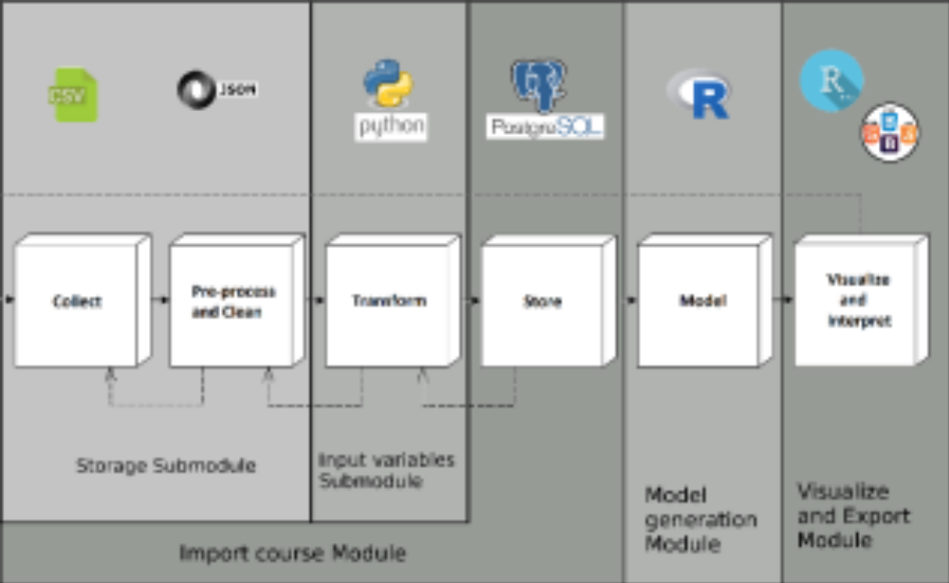
their insights regarding learners’ dropout. For this matter, a dropout definition based on association rules for automated tagging of learners by dropout, allowing to support non-supervised prediction approach was included. The rules have been created empirically by the exploration of extracted information of learners of a sample data of three courses of UAMx.
Fig. 1 edX-MAS Overview
3.1.1 DROPOUT IN edX COURSES
Although a number of reasons for student dropout have been suggested, there has been little research to assess how far these influence MOOC learners in practice or to identify which are within the sphere of influence of MOOC developers.
Various reasons for dropouts can be classified as:
- No real intention to complete
A number of authors have noted that reasons for participation given by users often include motivations such as “out of curiosity” and “to learn more about MOOCs” rather than to learn the subject itself.
- Lack of time
Students who fully intend to complete the course may fail to do so because they are unable to devote the necessary time to study.
- Course difficulty and lack of support
Related to the previous point is the level of difficulty of a course and the lack of necessary background. Insufficient mathematical skills are noted in relation to the Duke Bioelectricity course. As one respondent in Mackness et al’s survey said: “The reason I stopped is because I cannot understand the issues being discussed any more”.
- Lack of digital skills or learning skills
Online learning generally requires a high degree of autonomy and depends on users being able to work with the technologies and formats used. Even those who are familiar with using a range of everyday technologies may be uncomfortable when new systems must be quickly mastered.
- Bad experiences
Some MOOC participants have pointed to a variety of bad experiences as being a barrier to continued participation. These include: inappropriate behaviour of peers in forums; lack of focus and coordination in forums; depletion of study groups due to attrition; poor quality and incorrect learning materials; technical problems in the MOOC platform.
- Expectations
Students may enrol with little understanding of what the course requires and may have unrealistic expectations either of the course or of their own ability to undertake it.
- Starting late
Late starters on a course may find it very difficult to catch up and outcomes are likely to much lower for this group of students

3.1.2. Accreditation of edX courses
Some of the courses that are organised by MOOC providers, offered by MOOC platforms or partnerships lead to either certificate of completion, a badge or credit course. None of those are usually accredited, nor follow any general rules regarding certification of educational courses. Initially, MOOCs has not aimed at awarding credits at all. The possible confirmation of taking up a MOOC is a certificate of attendance of completion.
Various Challenges faced during certification and accreditation of MOOC’s:
- Accreditation models are not appropriate
The issue of awarding credits and issuing (accredited) certificates is inseparable from hardly responsive higher education and education and training systems, quality and economic reasons. In this section the key issues hampering recognition, accreditations and certification, commencing with the latter one will be considered.
- Courses themselves are free of charge
Obtaining any kind of evidence that one has been enrolled or completed such course is often issued upon a fee.
- Content of the courses keep on revolving
Due to the Technological advancement, since the foreign universities majorly focuses on the latest technologies, the content keeps on updating and hence it becomes difficult for the participants of the course to follow various patterns and thereby affecting their performance in the assignments.

As per course, relevant information from two different sources contained in edX UAM courses data is extracted. The first one includes all enrolled learners and their final results in the course (learner username, grade and type of certificate obtained). The second ones are log tracks, where it is possible to obtain event type (there are four critical types: navigation, problem, video or forum events), date and user identification. In addition, it is possible to obtain the date of last connection and number of connected days of each learner by loading and processing all their events. This information is represented as an activity matrix, which has one row per learner and one column per day of the course. Each element is a binary component, which denotes if the user has connected or not that day. The tool in course importation process exports the activity data and matrix, allowing later exploration, as explained below. With that representation, the calculation of connected days and inactivity days at the educational platform is simplified by counting and subtracting from and with the reference of the day course used to calculate the variable, respectively.
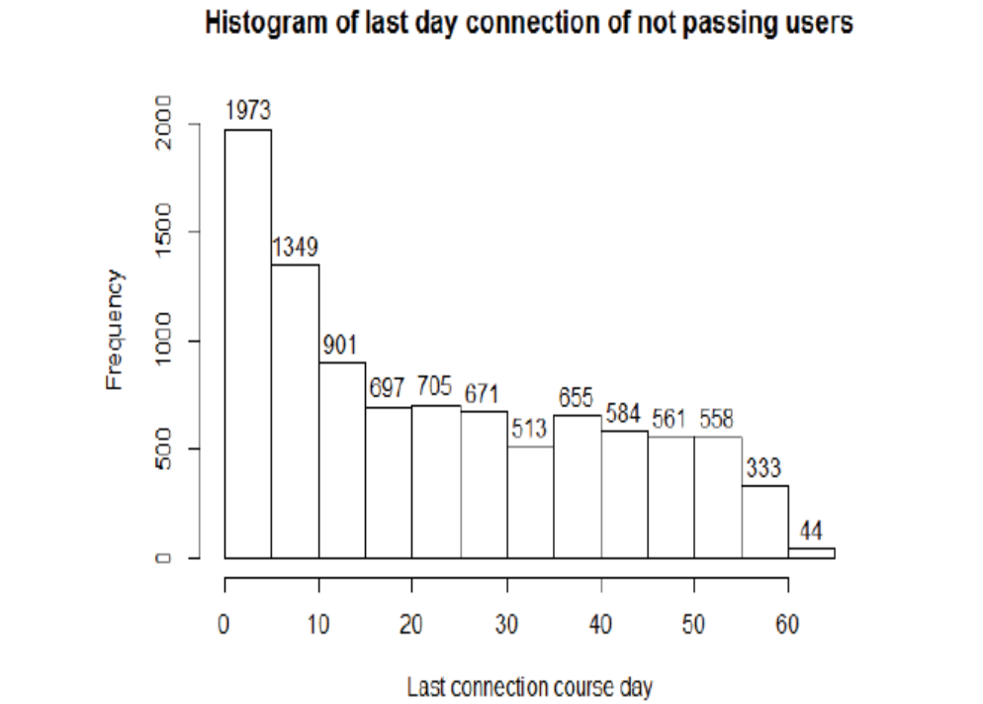
On selection of a sample data from three edX UAM courses (Quijote,Equidad and Renal, https://www.edx.org/school/uamx) and seven deliveries in total in 2015 and 2016, there is valid data on 10.919 learners for exploration. The 87,4% of them had not passed the course in which was enrolled. Exploring the 9.544 not passing, the 94,28% of them had connected less than ten, days and 51,55% had their last connection during the 20 first days of the course (see Fig. 2).

Fig. 2. Histogram of ordinal of the day of course as last day connection
of not passing users.

In addition, clustering was made with K-means algorithm with five clusters and Euclidean distance for analogy in Weka Exploration Mode, and we have obtained different groups by similarity with their grade, type of certificate and activity data: passing, not passing with activity, curious and not passing without activity. Passing means learners have 18 days of connection, and they work up to the 51 st day of the course (centroid values). Not passing with activity means learners have their last connection on the 46 th day but they had connected only 5,7 days on average. Curious learners have a grade close to 0, they connected 1,6 days on average, and they left the course at 5 th day on average. Not passing without activity refers to learners that left the course at 23 rd day on average and had only three days of activity on average.

Figure 3 shows the data clustering described: blue refers to passing learners, light blue with curious, red are not passing without activity (notpassing certificate type), pink ones are dropout learners with audit_notpassing certificate type (mixed not passing with activity and not activity), and finally, light green is not passing with activity.
Therefore, with this data analysis carried out, we have composed an empirical definition of dropout based on decision rules considering the following features for each learner: certificate type, number of activity days and last connection day. Provided below is the empirical definition. In referenced works there are compilations of other decision based dropout definitions and works, it can be compared in.
We select passing learners, i.e., they did not drop out. With non-passing learners, we review the number of activity days, and if it is less than 10% activity, they are tagged as a dropout (approximately six days of minimum activity is considered because course duration is 60 days on average). Otherwise, we check their last connection day, if it is higher than the last 21 days it is considered as not dropout: they had connected at the final week of the course or during the extra weeks for finishing exercises.

3.2 edX-MAS+ MODULES
Figure 1 illustrates an edX-MAS overview based on the Data Science process. edX-MAS is composed by three Modules:
1. Import course Module: it is composed by Storage Submodule and Input Variable Submodule. Thanks to these two modules only the relevant data extracted from the MOOC (log tracks) is processed and stored in the edX-MAS database.
2. Model generation Module: it supports the generation of predictive models for knowing which learners are going to earn a certificate and which of them will not.
3. Visualize and Export Module: it supports the visualization of the predictive models’ metrics and provides to export all the visualised information.

3.2.1 Import Course Module
This module allows extracting, cleaning, selecting and preprocessing course data for dropout detection and for selecting the relevant activity from the data collection. Moreover, it supports the creation of input variables and data storage management. It is coded in Python language. These following submodules compose this model.
Extraction and preprocessing Submodule:It is designed to extract and clean course data, preprocess and change its representation. In more detail, in this submodule, we construct the activity matrix, we filter events data by type and user, we list video and problem accessed by the user, and we integrate the decision rules of the dropout definition for automating the data-tagging task. This module exports this information to be used in input variables and storage submodules.

Input variables Submodule. This submodule calculates the input variables (indicators) for the course to import. These variables measure the following: time spent at the platform, time invested in problems, videos and forum, number of sessions and events registered (interaction indicators calculated by a summary of partial results of each day), and number of days connected. It also measures the consecutive inactivity days, and the number of different problems and videos accessed (activity indicators calculated from the start day of the course up to calculation model day). The following table shows the 15 indicators supported by the tool.

T ABLE I
INDICATORS CREATED IN EDX-MAS+ FOR EDX MOOC COURSE DATA
PER USER AND DAY

num_events | total_time | num_sessions
nav_events | nav_time | connected_days
video_events | video_time | consecutive_inactivity_days
problem_events | problem_time | num_diff_problems
forum_events | forum_time | num_diff_videos

The proposed list of attributes for the initial tool’s release are:
- nav_events: total number of events related to the navigation between the different contents of the course.
- nav_time: estimated time among navigation events.
- video_events: total number of events related with the interactions with the videos.
- video_time: estimated time among video events.
- forum_events: total number of events related to the course forums.
- forum_time: estimated time among forum events.
- problem_events: total number of events related with the interactions with the course problems.
- problem_time: estimated time among problem events.
- num_events: total number of events generated by the learner in the course.
- num_sessions: total number of sessions of the learner in the course. In determining a session within the edX MOOC, an inactivity threshold was established, if the elapsed time between two consecutive interactions of the learner exceeds the threshold, these interactions were assumed to have taken place in two separated sessions as the learner was considered not to have been active during this time.
- total_time: total time spent in the course (inactivity periods aside).

The design of this Submodule supports the generation of the attributes is a modular way, therefore, to add new attributes to the tool would be easy.
3.2.2 Model Generation Module
This module supports the generation of Predictive Models of the selected course per day or per week (two possible frequencies). The models are used to predict two situations: i) which learners have passed or not passed the course (certificate output variable) and ii) which learners have left or not the course (dropout output variable) with the selected input variables.
In more detail, the task is approached as supervised learning with repeated cross-validation training (75% of course input data) and testing (25% remaining) of different classification and regression algorithms (listed in Table 2).
This module is coded with R language, and the tool integrates ten Machine Learning algorithms available in R caret package and others associated (randomForest, arm, e1071, rpart, nnet). It stores the AUC, ROC and important variables statistics for later visualization.

T ABLE II
ALGORITHMS AVAILABLE IN EDX-MAS+ TOOL
Boosted Logistic Regression | Random Forest
Stochastic Gradient Boosting | Naïve Bayes
Extreme Gradient Boosting | Neuronal Network (one hidden  layer)
Support Vector Machines | Bayesian Generalized Linear Model
k-Nearest Neighbours | Classification and Regression Tree

The tool provides the use of these five machine learning algorithms for the predictive model generation:
- Boosted Logistic Regression or LogitBoost: it is a boosting algorithm formulated by Jerome Friedman, Trevor Hastie, and Robert Tibshirani. In the original research , they cast the AdaBoost (Adaptative Boosting) algorithm into a statistical framework. Specifically, if we consider AdaBoost as a generalized additive model and then apply the cost functional of logistic regression, we can derive the LogitBoost algorithm. It is available in R in the package LogitBoost.
- Stochastic Gradient Boosting or GBM: it is a boosting algorithm, similar to AdaBoost, which can be used for multi-class regression problems. GBM was first proposed by Freund and Schapire , and improved by Friedman . It is available in R in the package gbm.
- eXtreme Gradient Boosting or XGBoost: it is another boosting algorithm and related with previous one. This algorithm can generate decision trees which are human-readable models. It has a good performance as it includes an efficient linear model solver and can also exploit parallel computing capabilities . It is available in R in the package xgboost.
- Support Vector Machines or SVMs: They are supervised learning models with associated learning algorithms that analyze data used for classification and regression analysis. Given a set of training examples, each marked as belonging to one or the other of two categories, an SVM training algorithm builds a model that assigns new examples to one category or the other, making it a non-probabilistic binary linear classifier. The original SVM algorithm was invented by Vladimir N. Vapnik and Alexey Ya. Chervonenkis in 1963. The current standard incarnation (soft margin) was proposed by Corinna Cortes and Vapnik in 1993 and published in 1995 [13]. It is available in R in the package svmLinear.
- k-Nearest Neighbours Algorithm or kNN: it is a non-parametric method used for classification and regression. In both cases, the input consists of the k closest training examples in the feature space. The output depends on whether k-NN is used for classification or regression. k-NN is a type of instance-based learning, or lazy learning, where the function is only approximated locally and all computation is deferred until classification. The k-NN algorithm is among the simplest of all machine learning algorithms. It is available in R in the package kknn.
The design of this module was made in a modular way, therefore, to add other machine learning algorithms to the tool would be easy.
3.2.3. Visualize and Export Module
This module provides a visualization of the model metrics as graphics varying with the parameters selected in the Stats Predictive Models menu. The central panel interface contains five tabs (see Fig. 4):
1. AUC and Times includes a graphic with AUC values for the selected algorithm and a graphic with training and testing time for the course and delivery selected.
2. ROC includes graphics of ROC curves for each output variable (certificate and dropout) for the course and delivery selected.
3. Importance Variables, analogous as ROC tab for importance variable statistics.
4. Indicators show the username, indicators matrix, dropout classification, grade and certificate type obtained .
5. AUC Comparatives include lines graphics of AUC values for each day models. Also a graphic for comparing AUC values obtained in both output variables.

Fig. 4. Visualization of model statistics: AUC Comparatives tab.
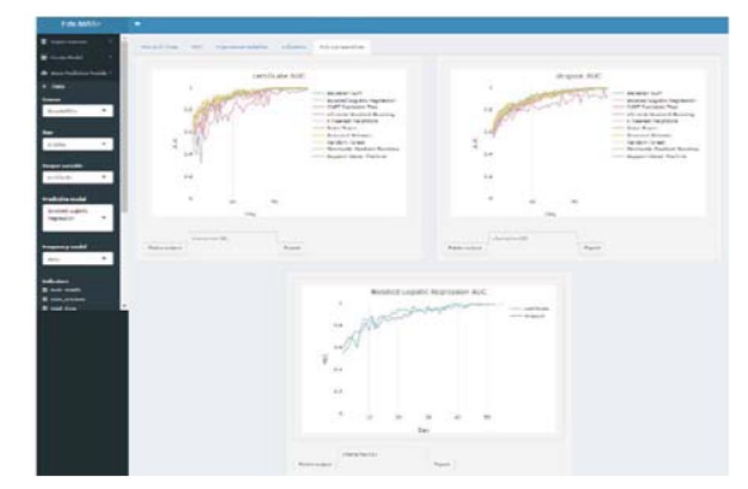
CHAPTER 4
RESULT

  - RESULTS OBTAINED WITH THE USE OF edX-MAS+
We have available data from seven MOOCs of two knowledge areas: Social Science and Science. Overall, we have fifteen course deliveries of 2015 and 2016 quarters, with 37.420 enrolled learners and available data on 18.927 learners of them for predictive models generation.
For each edition and course, we have imported the course with the edX-MAS+ tool, and we have created a total of 31.672.890 input variables (indicators). We have generated with the tool models with the possible output variables (certificate and dropout) and ten algorithms with fixed daily frequency and all types of indicators selected as input variables. The mean duration of the courses are 60 days, so edX-MAS+ database statistics of 18.000 models was stored approximately.
After visualizing and comparing statistics in the tool, on obtaining the following results (all the following graphics are obtained from edX-MAS+).

4.1.1 Results for both certificate and dropout prediction
• The algorithms that require more training time (in order descendent) are: Extreme Gradient Boosting, Random Forest, and Neuronal Network.
• The algorithm that requires more predicting time (or test time) is Naïve Bayes.
• The algorithms with worst precision (all AUC values are minor than the others algorithms values) are:
Classification and Regression Tree (CART), and k-Nearest Neighbours (kNN).
• The precision of certificate acquisition prediction is better than dropout prediction for all algorithms (see Fig. 4).

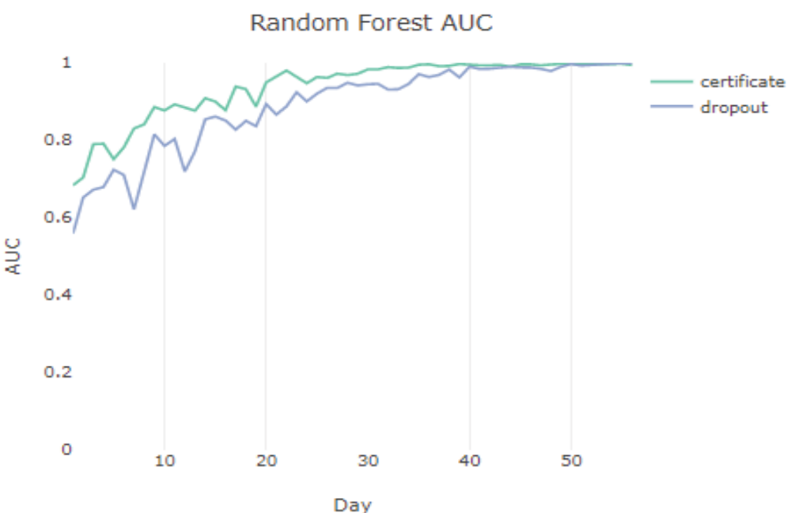
Fig. 5. Example of AUC values comparing both output variables for
Random Forest algorithm for Equidad course.

4.1.2 Results for certificate prediction
• The top five algorithms with better precision (best AUC daily model values) are: Bayesian Generalized Linear Model, Neuronal Network and Random Forest, followed by Stochastic Gradient Boosting and Naïve Bayes.
• For the best three algorithms, until the 20 th day of each course AUC daily values have a growing monotonous function, starting at 60%. From 20 th day AUC values are above 90%.
• The best algorithm Bayesian Generalized Linear Model was selected because it has less time for training and more stability than Neuronal Network and Random Forest (see Fig. 5).
• The best indicators, match for the best algorithms, are related with problems events: num_diff_problems (number of different problems accessed), problem_events and num_events (see Fig. 6).

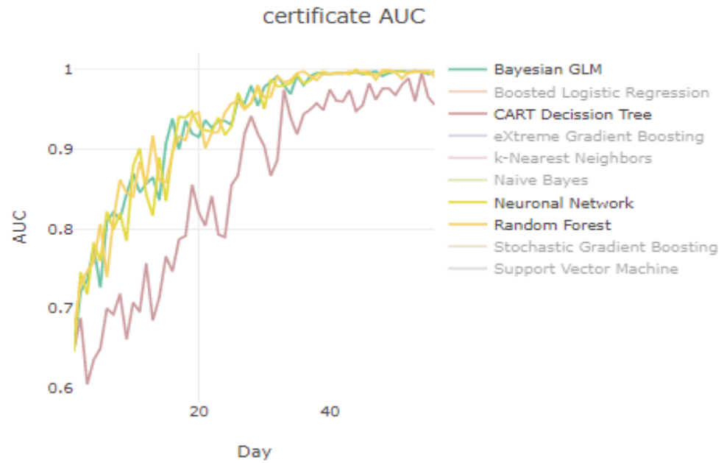
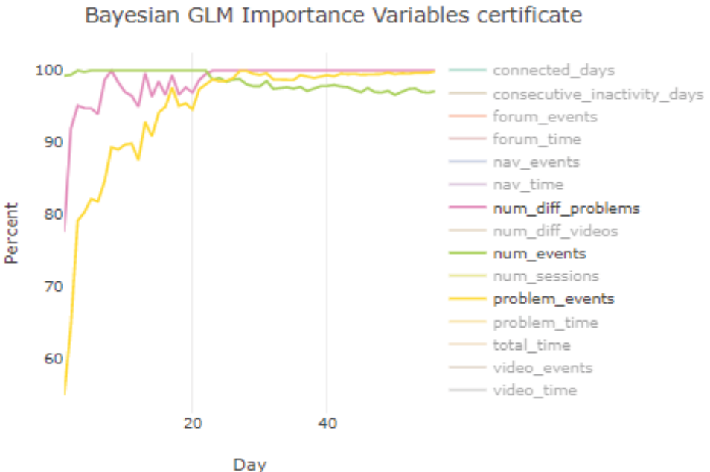
Fig. 6. Graphic of AUC values for certificate prediction in Renal course
on first term of 2016

Fig. 7. Graphic of importance variable statistic for Bayesian Generalized
Linear Model for Quijote third term 2015 certificate prediction.

    - Results for dropout prediction
- The top three algorithms with better precision (better AUC daily model values) are: Stochastic Gradient Boosting, Neuronal Network, and Random Forest.
- From the 20th day, the AUC value were obtained above 80% for the top three algorithms. The best indicators differ in some period of the course, at first third part the most relevant are num_events and num_sessions, the rest of the course connected_days (number of connected days).

CHAPTER 5
APPLICATIONS AND FUTURE WORK

5.1. APPLICATIONS OF edX-MAS
Firstly, when the tool was constructed only eight MOOCs at UAMx were available. From them, the tool was tested with two deliveries of five social science MOOCs and two deliveries of two science MOOCs. Course length in average is 60 days (the shortest course is six-weeks length and the longest one is nine-weeks length). Therefore 4.200 models were generated (7 courses x 2 deliveries x 5 machine learning algorithm x 60 days). Some obtained results are:
- The best machine learning algorithms are: XGBoost, GBM and SVMs. XGBoost looks to provide better performance in general for social science MOOCs and GBM for science ones.
- These pervious three mentioned machine learning algorithms offer over 95% accurate prediction, available approximately after the two thirds through the course delivery for all MOOCs.
- XGBoost need more time than the others in the training and test.
- k-NN looks to have the worst accuracy values with all MOOCs.
- The most relevant input variables (atributes) are related with problems (problem_events and problem_time) and the amount of events in the system (num_events).
- The less relevant input variables are related with forums (forum_events and forum_time).

Secondly, the last deliveries in 2016 of five MOOCs at UAMx contained a user questionnaire where learners were asked about their intentions to finish the course and to pay for a verified certificate among other questions.
Nowadays, work is being performed for the extraction of relevant information from this new dataset in order to contrast it with the data extracted thanks to the edX-MAS tool. Specifically, comparison is being performed on the learners’ performance in the courses, based in the attributes (input variables) extracted by the tool, with their answers in the questionnaire in order to identify learners patterns that could help us to extract good practices for learning with MOOCs.

5.2 FUTURE WORK
A modular and scalable tool is presented, which is called edX-MAS (Model Analyzer System for edX MOOCs) and it allows the simple application of a complete Data Science process, where Machine Learning algorithms are applied to generate predictive models which could be used to predict which learners have passed the course and therefore obtained a certificate.
In the future, the generation of more input/output variables will be added in the tools. More in detail, the tool will be extended with the prediction of dropout. Moreover, new learning machine algorithms will be included in the tool.
The obtained results offered by the tool will be use for the generation of warning systems that may automatically warn the learner at risk of not obtaining a certificate or dropout.

CHAPTER 6
CONCLUSION
This project presents a data analysis related with dropout in edX UAM MOOCs. This analysis allows integrating a dropout definition in the edX-MAS+ tool to automate student tagging by dropout, solving the problem of initial untagged data for the supervised classification approach. The dropout definition carried out is based on association rules which use features extracted from raw data of the student activity in the course. The proposed tool was tested with fifteen deliveries of seven MOOCs. It was generated approximately 18.000 models for certificate and dropout output variables using ten Machine Learning algorithms and fifteen indicators considered as input variables (activity, number of events and time invested related). As a result, the precision of predicting certificate acquisition is higher than the precision of predicting dropout for all algorithms. The best algorithms are Bayesian Generalized Linear Model for certificate prediction and Stochastic Gradient Boosting for dropout prediction, followed by Neuronal Network (with one hidden layer) and Random Forest in both cases. Their AUC values are above 90% and 80% from 20th day for certificate acquisition and dropout prediction, respectively.

CHAPTER 7
REFERENCES
- D.F.O., Onah, J. Sinclair, R. Boyatt, “Dropout Rates of Massive Open Online Courses: Behavioural Patterns”. The University of Warwick (United Kingdom).
- A. Sunar, S. White, N. Abdullah, D. Hugh. (2016), “How learners' interactions sustain engagement: A MOOC case study”. IEEE Transactions on Learning Technologies. Vol. 10, n. 4. 2016. 475–487. 10.1109/TLT.2016.2633268.
- Karolina Pietkiewicz, BizMOOC – BizMOOC – “Knowledge Alliance to enable a European-wide exploitation of the potential of MOOCs for the world of business”, Reference Number: 562286-EPP- 1-2015- 1-AT- EPPKA2-KA
Grant agreement number: 2015-2929 /001-01, 1/1/2016 – 31/12/2018.
- R. Cobos, V. Macías, “edX-MAS: Model Analyzer System”. In Proc of International Conference Technological Ecosystems for Enhancing Multiculturality 2017 (TEEM 2017), Cádiz, 2017.
- T. O’Riordan, D. Millard, J. Schulz, “How should we measure online learning activity?” Annual Conference 2015. School of Electronics and Computer Science, University of Southampton (UK) 2015.
- C. Milligan, A. Littlejohn, “Supporting professional learning in a massive open online course”. The International Review of Research in Open and Distributed Learning, [S.l.], vol. 15, n. 5, Oct. 2014. ISSN 1492-3831.
- A.F. Wise, Y. Zhao, S.N. Hausknecht, “Learning analytics for online discussions: a pedagogical model for intervention with embedded and extracted analytics”. In Proc of the Third International Conference on Learning Analytics and Knowledge (LAK '13), Dan Suthers, Katrien Verbert, Erik Duval, and Xavier Ochoa (Eds.). ACM, New York, NY, USA, 48-56. 2013.
- J.A. Ruipérez-Valiente, R. Cobos, P.J. Muñoz-Merino, A. Andújar, C. Delgado-Kloos, “Early Prediction and Variable Importance of Certificate Accomplishment”. In Proc of the European MOOC Stakeholder Summit 2017 (eMOOCs 2017). Leganés, Madrid, Spain, 22-26 May 2017.
- H. Martin, Z. Zdenek, Z. Jaroslav, “Ouroboros: Early identification of at-risk students without models based on legacy data”. In Proc of the Conference on Learning Analytics and Knowledge (LAK’17) Vancouver, BC, Canada, 2017.
- R. Ferguson, Z. Wei,Y. He, S. Buckingham Shum, “An evaluation of learning analytics to identify exploratory dialogue in online discussions”. In Proc of the Third Conference on Learning Analytics and Knowledge (LAK 2013), 8-12 April 2013, Leuven, Belgium.

